PROJECT REPORT
Team ID: LTVIP2026TMIDS91049
Project Title:

Rising Waters: A Machine Learning Approach To Flood Prediction
Team Members:
P Kiran Reddy
D Tulasi Prasad
Param Tharun kumar
Bandi Mounika

Phase-1: Brainstorming & Ideation

Objective:
To develop a machine learning–based flood prediction system that analyzes environmental and rainfall factors to predict the possibility of severe flooding. The system aims to support early warning systems, disaster preparedness, and decision-making for flood management.

Key Points:
● A machine learning–based application that predicts flood risk using environmental and rainfall data.
● Helps authorities and communities by providing early warnings to minimize damage and improve disaster response.
● Disaster management authorities who require early flood risk alerts.
● Government agencies responsible for urban planning and disaster control.
● Farmers and rural communities affected by seasonal flooding.
● Researchers and environmental analysts studying climate patterns.
● Floods are among the most destructive natural disasters, causing loss of life, infrastructure damage, and economic disruption. Traditional monitoring methods are slow and lack predictive accuracy.
● The system uses machine learning techniques to analyze rainfall patterns and environmental conditions to predict flood risk accurately, improving preparedness and reducing disaster impact.

1. Problem Statement:
Flood prediction using traditional methods is often inaccurate and delayed. There is a need for an automated intelligent system that can analyze environmental data and provide early flood warnings.

2. Proposed Solution:
Develop a machine learning model trained on rainfall and environmental data to predict flood risk and integrate it into a web-based interface for easy user access.

3. Target Users:
Disaster management authorities, government agencies, farmers, environmental researchers, and communities in flood-prone regions.

4. Expected Outcome:
● A functional machine learning application that predicts flood risk accurately.
● Provides early warning support for disaster preparedness.
● Enables faster decision-making to reduce flood damage.

Phase-2: Requirement Analysis

Objective:
Define the technical and functional requirements for the flood prediction system.

Key Points:
● Ability to input environmental parameters through the web interface.
● Predict flood risk using a trained machine learning model.
● Display prediction results clearly and instantly.
● Provide an easy-to-use interface accessible to all users.
● Ensuring accurate predictions despite environmental variability.
● Optimizing model performance for fast prediction.
● Designing a responsive and user-friendly web interface.

1. Technical Requirements:
Programming Language: Python
Python Packages:
NumPy, Pandas, Matplotlib, Seaborn, Scikit-learn, XGBoost, Joblib, Flask
Framework:
Flask for web integration
Machine Learning Models:
Decision Tree, Random Forest, K-Nearest Neighbors, XGBoost
Development Tools:
Jupyter Notebook, Anaconda, VS Code

2. Functional Requirements:
● Accept rainfall and environmental inputs from users.
● Process input using trained ML model.
● Predict flood risk.
● Display prediction results clearly.

3. Constraints & Challenges:
● Environmental variability affecting prediction accuracy.
● Ensuring high model accuracy.
● Maintaining fast response time.
● Designing a simple and responsive user interface.

Phase-3: Project Design

Objective:
Develop the architecture and user flow of the application.
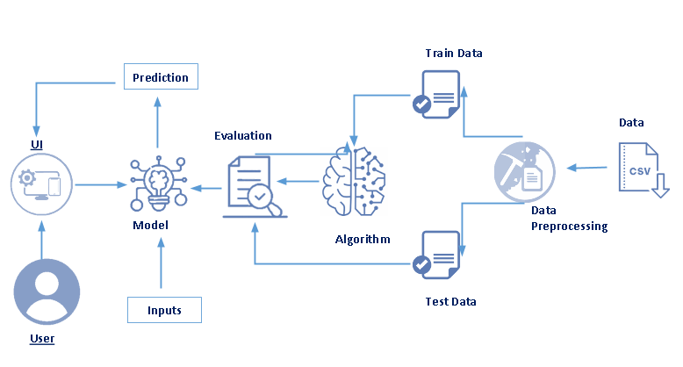

Key Points:
● Step 1: User opens the web application.
● Step 2: User enters environmental values.
● Step 3: The trained model processes the input data.
● Step 4: The system predicts flood risk.
● Step 5: Prediction result is displayed to the user.

1. System Architecture:
● User inputs environmental parameters via the web interface.
● Input data is preprocessed and scaled.
● The trained machine learning model processes the data.
● The system generates flood risk prediction.
● Results are displayed on the user interface.

2. User Flow:
● User navigates to the prediction page.
● Inputs rainfall and environmental values.
● Clicks the Predict button.
● System displays whether severe flooding is likely.

Phase-4: Project Planning

Objective:
Break down development tasks for efficient completion.
Sprint | Task | Priority | Duration | Dependencies | Assigned To | Expected Outcome
Sprint 1 | Environment Setup & Package Installation | High | 1 Hour | Anaconda, Python installation | Team Member 1 & 2 | Development environment ready
 | Dataset Collection | High | 1 Hour | Internet access, dataset source | Team Member 3 | Dataset downloaded
 | Dataset Loading & Verification | Medium | 1 Hour | Pandas library, dataset file | Team Member 2 | Dataset ready for analysis
Sprint 2 | Exploratory Data Analysis | High | 2 Hours | Clean dataset | Team Member 1 | Data patterns understood
 | Data Cleaning & Preprocessing | High | 2 Hours | Dataset, Pandas & NumPy | Team Member 2 | Clean & normalized data
 | Feature Scaling & Train-Test Split | High | 1 Hour | Preprocessed dataset | Team Member 3 | Data ready for training
Sprint 3 | Model Training | High | 3 Hours | Prepared dataset | Team Member 1 | Trained ML models
 | Model Evaluation & Comparison | High | 2 Hours | Trained models | Team Member 2 | Best model selected
 | Model Saving (Joblib) | Medium | 30 Minutes | Final model | Team Member 3 | Model ready for deployment
Sprint 4 | Flask Backend Development | High | 3 Hours | Saved model & scaler | Team Member 1 | Backend ready
 | UI Design (HTML/CSS) | Medium | 2 Hours | Frontend templates | Team Member 2 | User interface ready
 | Model Integration with Web App | High | 2 Hours | Backend & trained model | Team Member 3 | Functional web application
Sprint 5 | Functional Testing | High | 2 Hours | Complete system | Team Member 1 | Accurate predictions
 | Performance Testing | Medium | 1 Hour | Working application | Team Member 2 | Fast response time
 | Bug Fixing & Optimization | Medium | 1 Hour | Test results | Team Member 3 | Stable system
 | Final Deployment & Demo Preparation | High | 1 Hour | Completed application | Entire Team | Demo-ready system

Sprint Planning with Priorities

Sprint Planning with Priorities

Sprint 1 – Setup & Preparation
● Set up development environment.
● Install required Python packages.
● Collect and load dataset.
Expected Outcome: Environment ready & dataset prepared.

Sprint 2 – Model Development
● Perform data analysis and preprocessing.
● Train machine learning models.
● Compare model performance.
● Select best-performing model.
Expected Outcome: Trained flood prediction model.

Sprint 3 – Integration & Deployment
● Integrate model with Flask web application.
● Develop prediction interface.
● Test functionality and fix bugs.
● Prepare final deployment.
Expected Outcome: Working flood prediction web application.

Phase-5: Project Development

Objective:
Implement the core features of the flood prediction system using machine learning and web technologies.

1. Technology Stack Used:
Frontend: HTML, CSS, Bootstrap
Backend: Flask Framework
Machine Learning: Scikit-learn, XGBoost
Programming Language: Python

2. Development Process:
● Collected and analyzed environmental rainfall dataset.
● Performed univariate and multivariate data analysis.
● Preprocessed data including handling outliers and feature scaling.
● Trained multiple machine learning models.
● Selected XGBoost as the final model with highest accuracy.
● Saved trained model and scaler.
● Integrated model into Flask web application.
● Developed user interface for prediction input and results.

3. Challenges & Fixes:
● Challenge: Environmental variability affected prediction accuracy.
Fix: Used feature scaling and model comparison techniques.
● Challenge: Model response time needed optimization.
Fix: Selected efficient XGBoost model and saved using Joblib.
● Challenge: Ensuring user-friendly interface.
Fix: Designed simple and responsive web layout.

Phase-6: Functional & Performance Testing

Objective:
Ensure the flood prediction system performs accurately and reliably.
Test Case | Scenario | Expected Outcome | Status
TC-001 | Valid rainfall input | Correct prediction | ✅ Passed
TC-002 | High rainfall values | Flood risk detected | ✅ Passed
TC-003 | Low rainfall values | No flood risk | ✅ Passed
TC-004 | Extreme inputs | Reasonable prediction | ✅ Passed
TC-005 | Mobile responsiveness | Layout adjusts | ✅ Passed
TC-006 | Prediction speed | Under 2 seconds | ✅ Passed

Results
● Model Accuracy: ~96.55%
● Fast prediction response time
● Accurate flood risk detection
● Successful web deployment

Conclusion
The flood prediction system successfully predicts the possibility of severe flooding using machine learning techniques. By analyzing rainfall and environmental data, the system provides reliable predictions through a web interface. This solution enhances disaster preparedness and supports early warning systems, helping reduce the impact of flood disasters.

Future Enhancements
● Integration with real-time weather APIs
● Mobile application development
● GIS-based flood zone mapping
● SMS alert system for early warnings
● Cloud deployment for scalability

